Name: Patel Jay Hiteshkumar

Id:20BCA86

Div: B

1.Print current month calendar.

Code:

$ cal

Output:

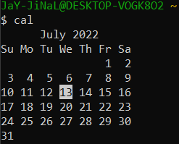

2. Print calendar of May, June and July of previous year.

Code:

$ cal -3 22 06 2021

Output:

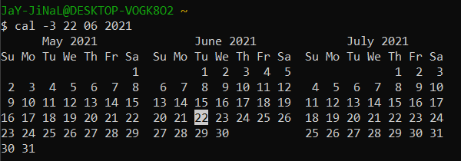

3. Convert decimal number to hexadecimal.

Code:

bc

obase=16

Output:

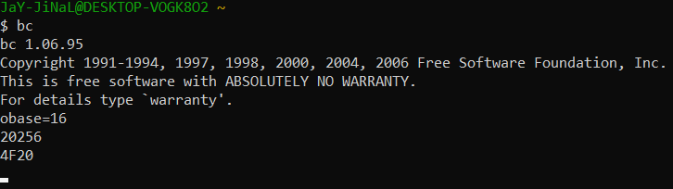

4. Display following message by applying one command.

Hello Everyone.

Today's Date is: (Example: 12 jul 2021)

Code:

$ echo "Hello Everyone"; echo "Today Date Is: "; date "+ %d %b %y";

Output:

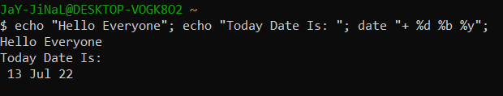

5. Display following message by applying one command.

Hello Everyone.

Today is <Print weekday name is long >(Example: today is Sunday)

Code:

$ echo "Hello Everyone"; echo "Today Day Is:" ; date "+%A";

Output:

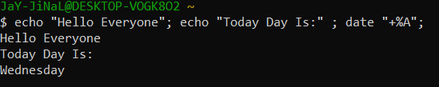

6. Check your current directory.

Code:

$pwd

Output:

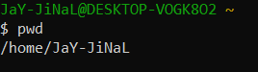

7. create a folder "UNIX", "ASP" and "PHP" in "v:\" drive.

Code:

$ cd /cygdrive/f

$ mkdir UNIX ASP PHP

Output:



8. move to Directory "UNIX".

Code:

cd Unix

Output:



9. Create 2 more directories "Assignment" and "Test" in "UNIX" Directories

Code:

$ mkdir Assignment Test

Output:



10. move to Directory "PHP" With only one command

Code:

cd../PHP

Output:



11. Create a directory "Web" under "ASP" Directory without moving from the "PHP" directory.

Code:

mkdir../ASP/Web

Output:



12. Create Directory "Project", "Temp" & "Exam" under "Web" directory resides in "ASP" Without moving from "PHP" directory.

Code:

$ mkdir ../ASP/Web/Project ../ASP/Web/Temp ../ASP/Web/Exam

Output:



13.Create empty files "test1","test2" & "test3" in one command in current directories.

Code:

$ touch test1 test2 test3

Output:



14. Display Previous working directory

Code:

Cd ../; ls

Output:

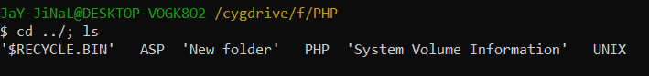

15. Write 3 different way to move to home directory

Code:

1)-> cd

2)-> cd ~

3)-> cd $HOME